- How Linked List is used in popular languages like Python, Java, and C++. None of these languages use linked lists to store linear. All of them provide dynamically growable lists but none of these implementations are linked lists. They are ordinary lists. They provide linked lists as separate implementations. Find reasons for this.
- Formatting the entire document.
- Algorithm formats may need to be changed.

Assignment: Set a <- b.
Control: While End While, If End If, If Else, For End For, Return. Use standard english sentences, eg. Create new Node (newNode)
If head = NULL then, While temp.next != NULL do

Introduction

Linked List is an example of conceptual data structure, where each node is connected to its logical previous and logical next node. The logical next and previous nodes of the node under consideration are not connected among themselves. This definition results in a linear arrangement of nodes.

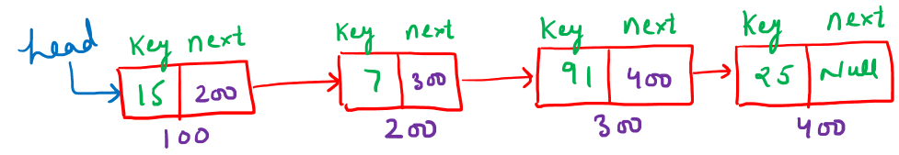
Access to this data structure is usually through a single node called the head of the list. Order of nodes is not defined by their physical placement in memory. The nodes may be physically scattered throughout the memory. The relationship between a node and its next node is merely logical in nature.

Use Case:

The two most commonly encountered use cases.
- When we need fast access.
- When the size of data is dynamic.

While Arrays are used in the first case, Linked List is used in the second case.

Limitations of Linked List
- Access time will be O(n) compared to O(1) in case of arrays.
- Requires more memory for storing references apart from the key.

Types of Linked Lists

Singly Linked List
The most basic type of linked list, wherein each node is connected to its logical next node only.
Entry to the data structure is through the first node called the head node. Mark head node. Each node maintains the value of the key and a reference to its logical next.
Operations:
We will cover the following four basic operations:

Creation
Given a data value value, create a new linked-list node and return it.

Algorithm createANode(value)
- allocate memory for newNode
- set newNode.data <- value.
- set newNode.next <- NULL.
- return newNode.

C++ Code
class Node {
public: int data;
Node * next;

// Constructor
Node(int value) {
data = value;
next = nullptr;
}
};

// Function to create a new node
Node * createNode(int value) {
// call constructor
Node * newNode = new Node(value);
return newNode;
}

int main() {
int value;
cin >> value;

Node * node = createNode(value);

cout << "Node created successfully!" << endl;
cout << "Data = " << node -> data << endl;
// will display 0 or NULL
cout << "Next = " << node -> next << endl;

return 0;
}
Complexity
Complexity of creating a node is O(1)

Searching
Given a linked list starting at head and a value searchKey, determine whether the key is present in the list.
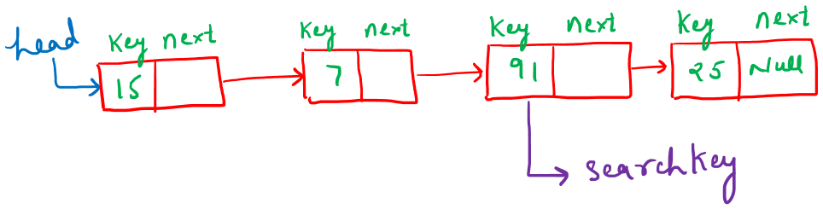

Algorithm search(value)
- set temp <- head
- while temp != NULL do
  - if temp.data = key then
i. return true
b. end if
- set temp <- temp.next
- end while
- return false
C++ Code
#include <iostream>

using namespace std;

class Node {
public: int data;
Node * next;

Node(int value) {
data = value;
next = nullptr;
}
};

bool search(Node * head, int key) {
Node * current = head;

while (current != nullptr) {
if (current -> data == key) {
return true; // key found
}
current = current -> next; // move to next node
}

return false; // key not found
}

int main() {
// Creating a simple linked list manually: 10 -> 20 -> 30
Node * head = new Node(10);
head -> next = new Node(20);
head -> next -> next = new Node(30);

int key;
cin >> key;

if (search(head, key)) {
cout << "Found\n";
} else {
cout << "Not Found\n";
}

return 0;
}

Complexity of Linear Search
The complexity of the search operation is O(n).
 | How much time will it take to find the k^th element from the end in a given linear linked list of n nodes?
A | O(n)
B | O(n^2)
C | O(nlog n)
D | None of the above

Insertion
Inserting the given key into the structure. Insertion is possible in 4 different ways:
- At beginning
- At end
- At any index
- After some particular value.
Insertion at Beginning
Insert a given node (newNode) in a Singly Linked List at the first position. You are given the reference of the first node of the SLL (head). The newNode has two fields (key and next). The key field has some value and the next field is None.
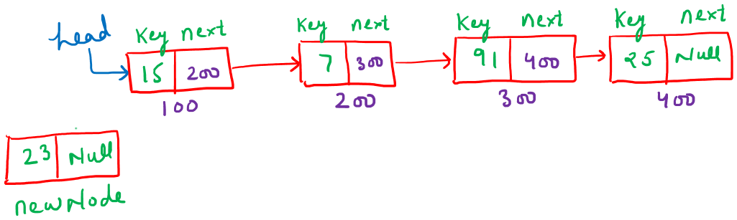

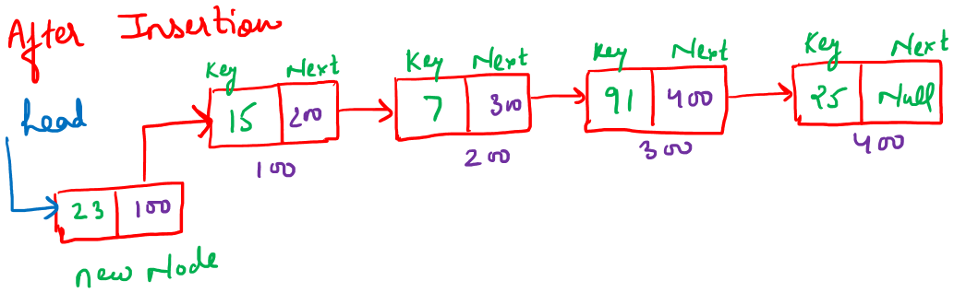
Algorithm insertAtBeginning(head, value)
- create a new node (newNode)
- set newNode.data <- value
- set newNode.next <- NULL
- set head <- newNode
- return head

C++ Code
Node* insertAtBeginning(Node* head, int value) {
Node* newNode = new Node(value); // Create new node.
newNode->next = head; // New node points to the old head.
head = newNode; // Update head.
return head; // Return new head.
}
Complexity
Every statement of the above algorithm is a constant time operation. Hence Insertion at the beginning is of constant time i.e. O(1).
Insertion at the End
Insert a given node (newNode) in a Singly Linked List at the last position. You are given the reference of the first node of the SLL (head). The newNode has two fields (key and next). The key field has some value and the next field is None.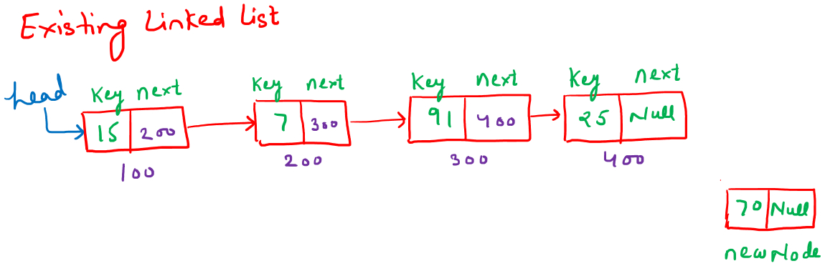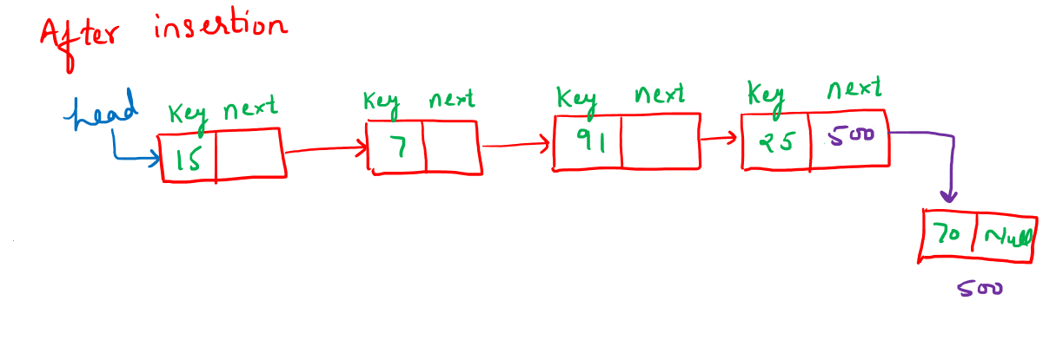
Algorithm insertAtEnd(head, value)

- create a new node (newNode)
  - set newNode.data <- value
  - set newNode.next <- NULL
- if head = NULL then
  - set head <- newNode
  - return head
- end if
- set temp <- head
- while temp.next != NULL do
  - set temp <- temp.next
- end while
- set temp.next <- newNode
- return head
C++ Code
Node * insertAtEnd(Node * head, int value) {
Node * newNode = new Node(value); // create new node

// If list is empty
if (head == nullptr) {
return newNode; // new node becomes head
}

Node * temp = head;

// Traverse to the last node
while (temp -> next != nullptr) {
temp = temp -> next;
}

temp -> next = newNode; // link new node at end
return head; // return unchanged head
}
Complexity
We must traverse the entire list to reach the last node as we are maintaining only head pointer. So the complexity is O(n).
Insertion at the end in SLL can be implemented in O(1) time complexity if we maintain the reference to the last node of the SLL. This better approach is presented below in the form of Pseudo Code.
Insertion at end (Special Case)
Insert a given node (newNode) in a Singly Linked List at the last position. You are given the reference of the first node and the last node of the SLL (head and tail respectively). The newNode has two fields (key and next). The key field has some value and the next field is None.
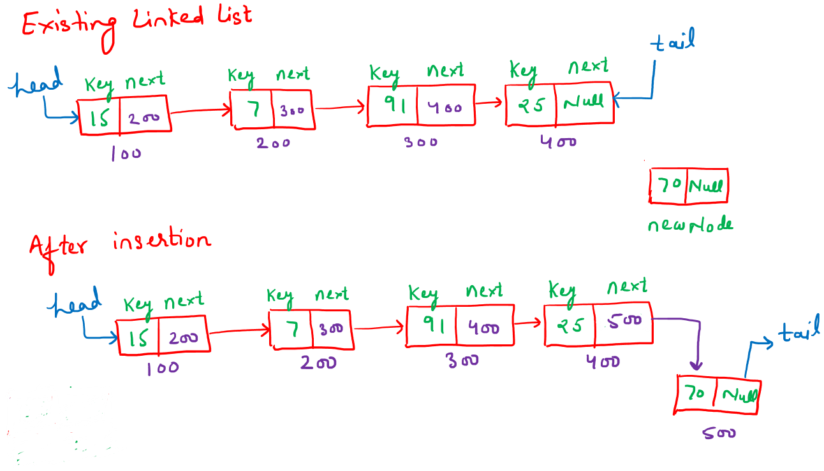
Algorithm insertAtEnd(head, tail, value)
- create a new node (newNode)
  - set newNode.data <- value
  - set newNode.next <- NULL
- if head = NULL then
a. set head <- newNode
b. set tail <- newNode
- return
- end if
- set tail.next <- newNode
- set tail <- newNode

C++ Code
void insertAtEnd(Node * & head, Node * & tail, Node * newNode) {

// If list is empty
if (head == nullptr) {
head = newNode;
tail = newNode;
return;
}

// Attach at the end
tail -> next = newNode;

// Update tail pointer
tail = newNode;
}
Complexity
Complexity of Insertion at the end operation using a tail reference to the last node is of constant time i.e. O(1).
Insertion at given Index
Insert a given node (newNode) in a Singly Linked List at a given index (index). It can be assumed that the value of index >= 0 and index <= length of Singly Linked List - 1. You are given the reference of the first node of the SLL (head). The newNode has two fields (key and next). The key field has some value and the next field is None.
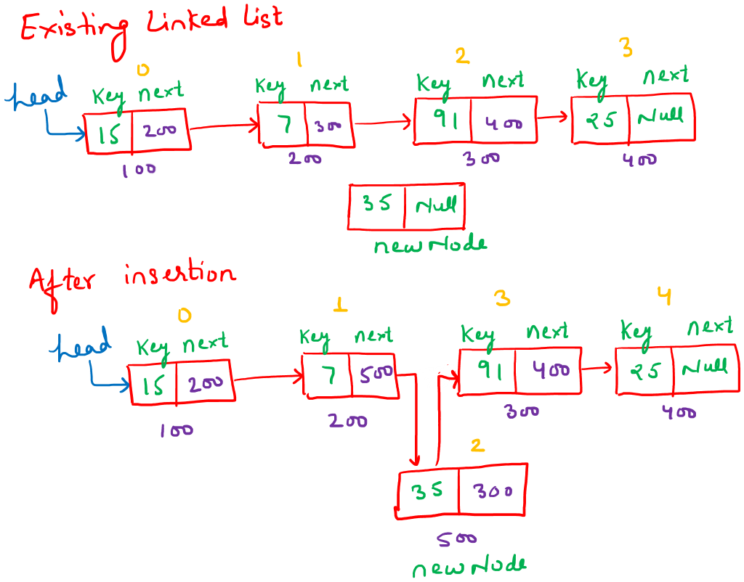

Algorithm: InsertAtIndex(head, index, value)

- Create a new node (newNode)
- set newNode.data <- value
- set newNode.next <- NULL
- if index = 0 then
- set newNode.next <- head
- return newNode
- end if
- if temp = NULL then
- print “index out of range”
- delete newNode
- return head
- end if
- set temp <- head
- set currentIndex <- 0
- while temp != NULL and currentIndex < index - 1 do
- set temp <- temp.next
- set currentIndex <- currentIndex + 1
- end while
- set newNode.next <- temp.next
- set temp.next <- newNode
- return head

C++ Code
Node * insertAtIndex(Node * head, int index, int value) {
Node * newNode = new Node(value);

// Insert at beginning
if (index == 0) {
newNode -> next = head;
return newNode;
}

// If index is out of bounds
if (temp == nullptr) {
cout << "Index out of range!\n";
delete newNode;
return head;
}

Node * temp = head;
int currentIndex = 0;

// Move to (index - 1) position
while (temp != nullptr && currentIndex < index - 1) {
temp = temp -> next;
currentIndex++;
}

// Insert node
newNode -> next = temp -> next;
temp -> next = newNode;

return head;
}
Complexity of Insertion
The above algorithm traverses upto the point of insertion of the node . Hence the algorithm has linear time complexity O(n).
Insert after some particular value
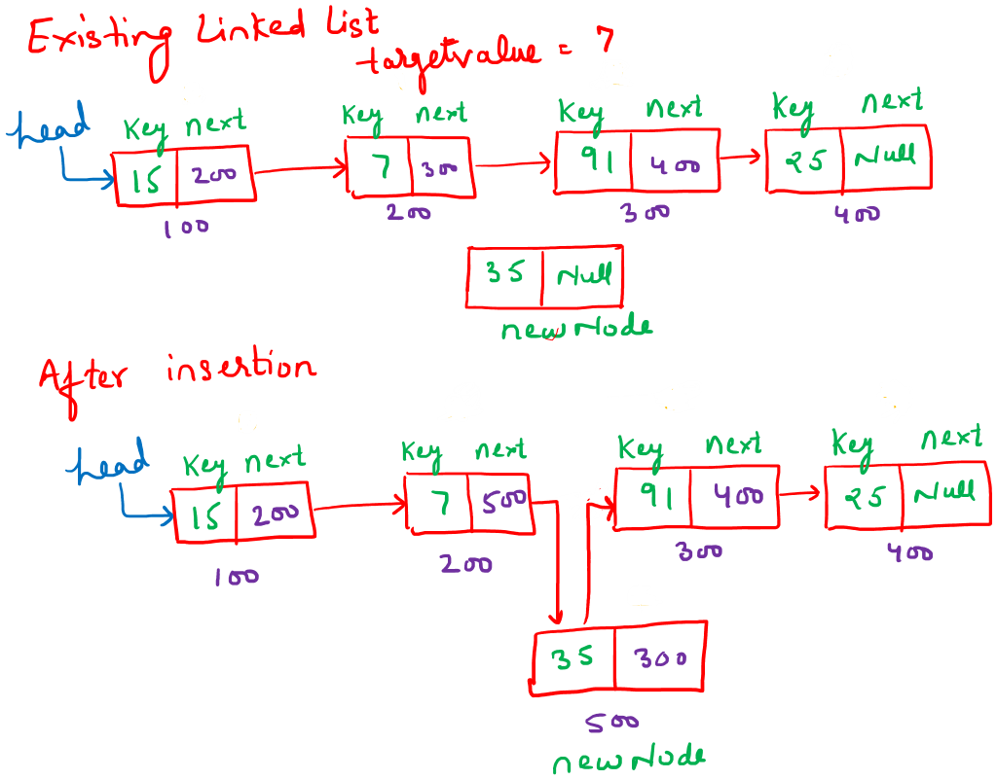
Algorithm insertAfterValue(head, target, value)

- create a new node (newNode)
- set newNode.data <- value
- set newNode.next <- NULL
- if temp = NULL then
- print "value not found"
- return head
- end if
- set temp <- head
- while temp != NULL and temp.data != target do
  - set temp <- temp.next
- end while
- set newNode.next <- temp.next
- set temp.next <- newNode
- return head
C++ Code
Node * insertAfterValue(Node * head, int target, int value) {
if (temp == nullptr) {
cout << "Value " << target << " not found in the list!\n";
return head;
}
Node * temp = head;

// Traverse to find the target value
while (temp != nullptr && temp -> data != target) {
temp = temp -> next;
}
// Insert new node after target
Node * newNode = new Node(value);
newNode -> next = temp -> next;
temp -> next = newNode;

return head;
}

Complexity
The above algorithm traverses upto the point of insertion of the node . Hence the algorithm has linear time complexity O(n).

Deletion
Delete the given key from the structure. Deletion is possible in 4 different ways:
- from beginning
- At end
- At any index
- Node with some particular value.
Deletion from the Beginning
You are given the reference of the first node of the SLL (head). Delete the first node of this linked list.
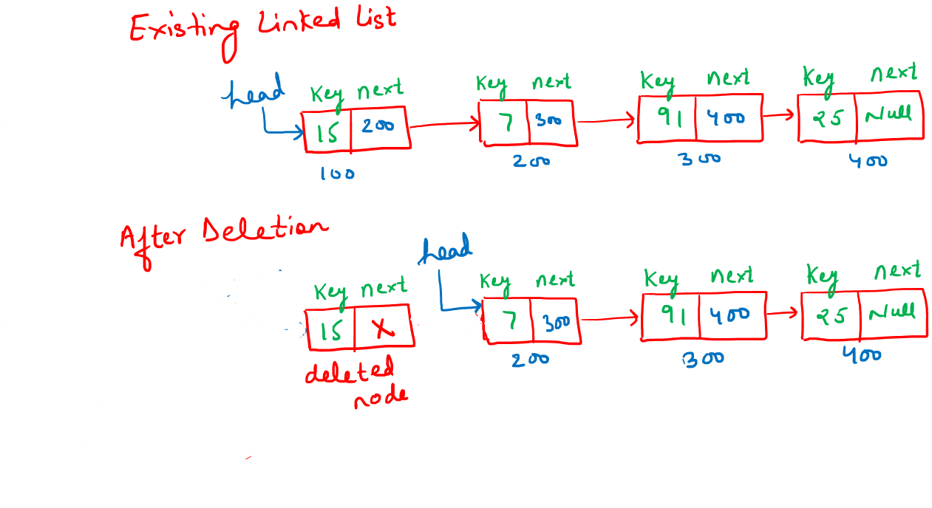
Algorithm deleteFromBeginning (head)
- if head = NULL then
- print "list is empty"
- return NULL
- End if
- set temp <- head
- set head <- head.next
- delete temp
- return head
C++ Code.
Node * deleteFromBeginning(Node * head) {
if (head == nullptr) {
cout << "List is empty, nothing to delete.\n";
return nullptr;
}

Node * temp = head; // Store the current head
head = head -> next; // Move head to the next node
delete temp; // Free memory of the old head

return head; // Return the new head
}

Complexity

Every statement of the above algorithm is a constant time operation. Hence deletion from the beginning is of constant time i.e. O(1).
Deletion from end
You are given the reference of the first node of the SLL (head). Delete the last node of this linked list.
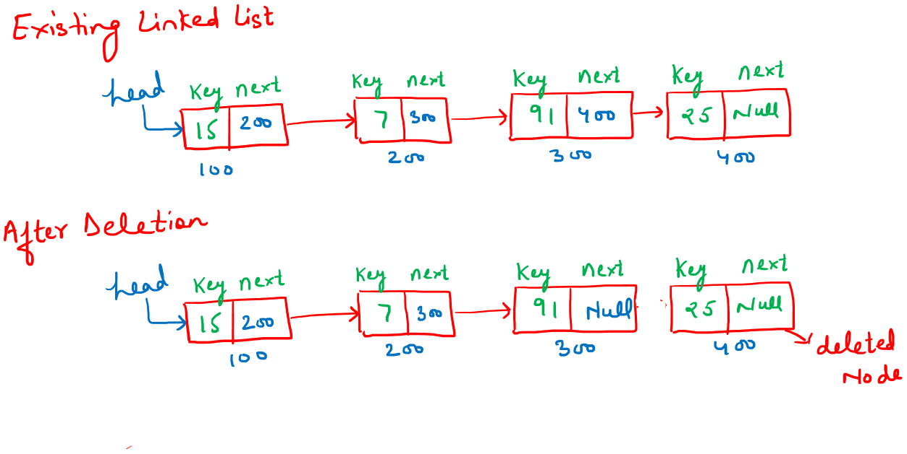
Algorithm deleteFromEnd (head)
- if head = NULL then
- print "list is empty"
- return NULL
- end if
- if head.next = NULL then
- delete head
- return NULL
- end if
- set temp <- head
- while temp.next.next != NULL do
- set temp <- temp.next
- end while
- delete temp.next
- set temp.next <- NULL
- return head
C++ Code
Node * deleteFromEnd(Node * head) {
if (head == nullptr) {
cout << "List is empty, nothing to delete.\n";
return nullptr;
}

// If there's only one node
if (head -> next == nullptr) {
delete head;
return nullptr;
}

// Traverse to the second-last node
Node * temp = head;
while (temp -> next -> next != nullptr) {
temp = temp -> next;
}

// Delete the last node
delete temp -> next;
temp -> next = nullptr;

return head;
}

Complexity
We must traverse the entire list to reach the last node as we are maintaining only the head pointer. So the complexity is O(n).
Deletion from the end (Special Case)
You are given the reference of the first node of the SLL (head)and the reference of the second last node of the SLL (prevTail). Delete the last node of this linked list.
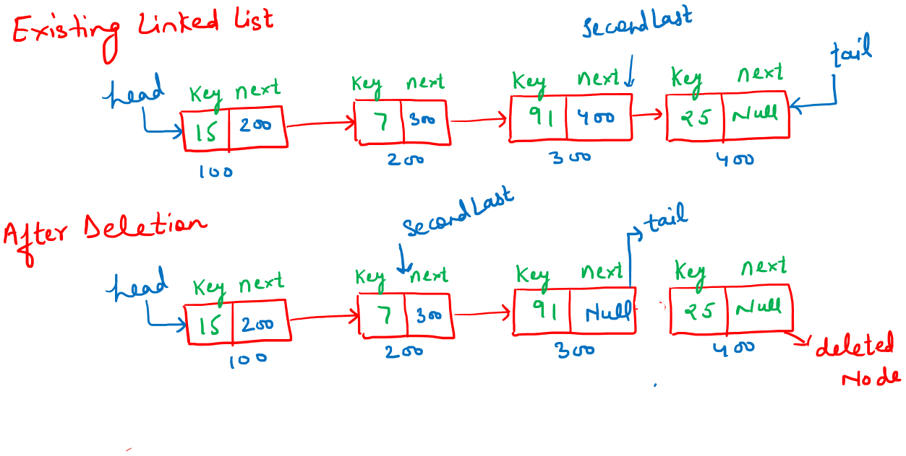Algorithm deleteLastNode(head, prevTail)
- if head = NULL then
- print "list is empty"
- return NULL
- End if
- if prevTail = NULL then
- delete head
- return NULL
- end if
- delete prevTail.next
- set prevTail.next <- NULL
- return head

C++ Code
// Delete the last node given the reference to second-last node
Node * deleteLastNode(Node * head, Node * prevTail) {
if (head == nullptr) {
cout << "List is empty, nothing to delete.\n";
return nullptr;
}

// If list has only one node
if (prevTail == nullptr) {
delete head;
return nullptr;
}

// Delete the last node
delete prevTail -> next;
prevTail -> next = nullptr;

return head;
}
Complexity:
Since the reference of the second last node is given therefore the complexity is O(1). Note that if the reference of only the tail node is given then the complexity is O(n).
Deletion at the given index
Delete a node in a Singly Linked List from a given index (index). It can be assumed that the value of index >= 0 and index <= length of Singly Linked List - 1. You are given the reference of the first node of the SLL (head). It can also be assumed that the list has at-least one node.
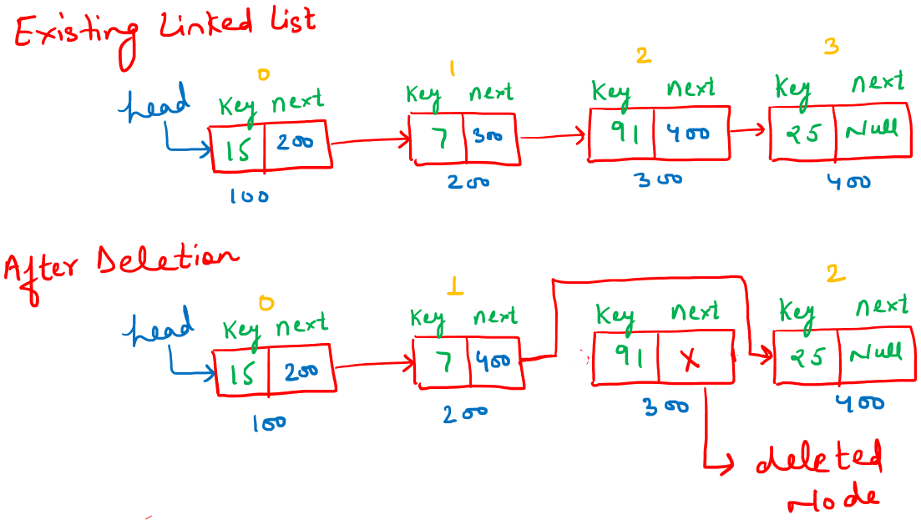
Algorithm deleteAtIndex(head, index)
- if head = NULL then
- print "list is empty"
- return NULL
- end if
- if index = 0 then
- set temp <- head
- set head <- head.next
- Delete temp
- return head
- end if
- set temp <- head
- set currentIndex <- 0
- while temp != NULL AND currentIndex < index - 1 do
- set temp <- temp.next
- set currentIndex <- currentIndex + 1
- end while
- set nodeToDelete <- temp.next
- set temp.next <- nodeToDelete.next
- delete nodeToDelete
- return head

C++ Code
Node * deleteAtIndex(Node * head, int index) {
if (head == nullptr) {
cout << "List is empty, nothing to delete.\n";
return nullptr;
}

// Delete the first node
if (index == 0) {
Node * temp = head;
head = head -> next;
delete temp;
return head;
}

// Traverse to the node just before the index
Node * temp = head;
int currentIndex = 0;
while (temp != nullptr && currentIndex < index - 1) {
temp = temp -> next;
currentIndex++;
}

// Delete the node at index
Node * nodeToDelete = temp -> next;
temp -> next = nodeToDelete -> next;
delete nodeToDelete;

return head;
}
Deletion after a given value
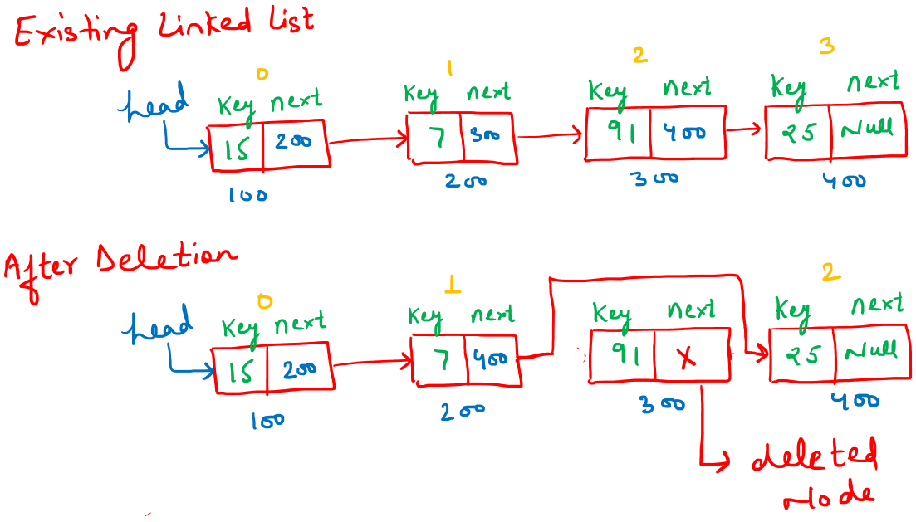
Algorithm deleteAfterValue(head, targetValue)
- set temp <- head
- while temp != NULL and temp.key != targetValue do
- set temp <- temp.next
- end while
- if temp = NULL or temp.next = NULL then
- return head
- end if
- set delNode <- temp.next
- set temp.next <- delNode.next
- delete delNode
- return head

C++ Code
Node * deleteAfterValue(Node * head, int targetValue) {
Node * temp = head;
while (temp != NULL && temp -> key != targetValue) {
temp = temp -> next;
}
if (temp == NULL || temp -> next == NULL) {
return head;
}
Node * delNode = temp -> next;
temp -> next = delNode -> next;
delete delNode;

return head;
}

Complexity

The complexity of the given algorithm is O(n).

Suppose there is a singly linked list having unsorted elements. Also, given that it has a head pointer referring to the first node and a tail pointer referring to the last node. Then, what will be the time complexity of the following operations?
1.Insertion at the front of the linked list
2.Insertion at the end of the linked list
3.Deletion of the front node of the linked list
4.Deletion of the last node of the linked list
A | O(1), O(n), O(1), O(n)
B | O(1), O(n), O(n), O(n)
C | O(1), O(1), O(1), O(n)
D | None of the above
AN | C

Gate Questions SLL

 | GATE 2022
Consider the problem of reversing a singly linked list. To take an example, given the linked list below,
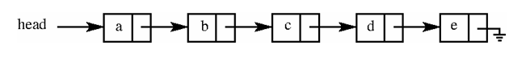the reversed linked list should look like
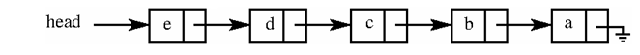
Which one of the following statements is TRUE about the time complexity of algorithms that solve the above problem in (1) O space?
A | The best algorithm for the problem takes (n) time in the worst case.
B | The best algorithm for the problem takes (n log n) time in the worst case.
C | The best algorithm for the problem takes (n2) time in the worst case.
D | It is not possible to reverse a singly linked list in O(1) space.
AN | A

 | GATE 2025
Let LIST be a datatype for an implementation of linked list defined as follows:

typedef struct list {
int data;
struct list *next;
} LIST;

Suppose a program has created two linked lists, L1 and L2, whose contents are given in the figure below (code for creating L1 and L2 is not provided here). L1 contains 9 nodes, and L2 contains 7 nodes.

Consider the following C program segment that modifies the list L1. The number of nodes that will be there in L1 after the execution of the code segment is ________ . (Answer in integer) Gate Question (Q-62 2025 CS1)

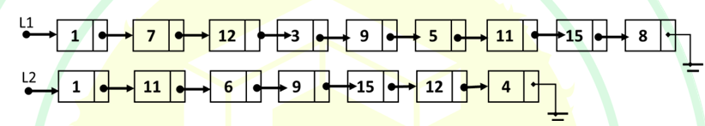

int find (int query, LIST *list) {
while (list != NULL) {
if(list->data == query) return 1;
list = list->next; }
return 0; }

int main () {
...
ptr1=L1; ptr2=L2;
while (ptr1->next != NULL) {
query = ptr1->next->data;
if (find (query, L2))
ptr1->next = ptr1->next->next;
else
ptr1 = ptr1->next;
}
...
return 0; }
AN | 5

 | GATE 2025
 | Consider an unordered list of 𝑁 distinct integers. What is the minimum number of element comparisons required to find an integer in the list that is NOT the largest in the list?
A | 1
B | N - 1
C | N
D | 2N - 1
AN | A

 | GATE 2005
 | What is the time complexity of searching an element in a singly linked list of n nodes?
AN | O(n)

 | GATE 2014
 | What is the time complexity of inserting a node at the beginning of a linked list?
AN | O(1)

 | GATE 2016
 | What is the time complexity of deleting the last node from a singly linked list when only the head pointer is given?
AN | O(n)

 | GATE 2008
Given the following structure:

struct node {
int data;
struct node *next;
};

How many bytes are required for one node on a 32-bit system?
AN | 8 bytes (4 bytes int + 4 bytes pointer)

 | GATE 2011
 | In a singly linked list, which node cannot be deleted in O(1) time if only a pointer to that node is given?
AN | Last node

 | GATE 2012
 | What happens if a loop exists in a linked list and traversal is done using while(node != NULL)?
AN | Infinite loop

 | GATE 2006
 | Which data structure is best suited for frequent insertions and deletions in the middle?
AN | Linked List

 | GATE 2017
 | Is it possible to reverse a singly linked list using recursion?
AN | Yes

 | GATE 2021
 | Which of the following operations cannot be done efficiently using a singly linked list?
AN | Accessing the kth element in O(1)

 | GATE 2002
 | In the worst case, the number of comparisons needed to search a single linked list of length n for a given element is
A | log n
B | n/2
C | log₂ n − 1
D | n
AN | D

 | GATE 2003
Consider the function f defined below.

struct item {
int data;
struct item * next;
};

int f(struct item * p)
{
return ((p == NULL) || (p -> next == NULL) ||
((p -> data <= p -> next -> data) &&
f(p -> next)));
}
For a given linked list p, the function f returns 1 if and only if
A | the list is empty or has exactly one element
B | the elements in the list are sorted in non-decreasing order of data value
C | the elements in the list are sorted in non-increasing order of data value
D | not all elements in the list have the same data value
AN | B

 | GATE 2024
Let P be a singly linked list. Let Q be the pointer to an intermediate node x in the list.
What is the worst-case time complexity of the best-known algorithm to delete the node x from the list?
A | O(n)
B | O(log⁡2n)
C | O(log⁡n)
D | O(1)
AN | D

 | GATE 2004
 | Suppose each set is represented as a linked list with elements in arbitrary order. Which of the operations among union, intersection, membership, cardinality will be the slowest?
A | union only
B | intersection, membership
C | membership, cardinality
D | union, intersection
AN | D

 | GATE 2005, GATE 2008
The following C function takes a singly-linked list of integers as a parameter and rear ranges the elements of the list. The list is represented as pointer to a structure. The function is called with the list containing the integers 1, 2, 3, 4, 5, 6, 7 in the given order. What will be the contents of the list after the function completes execution?

struct node {
int value;
struct node * next;
};

void rearrange(struct node * list) {
struct node * p, * q;
int temp;

if (!list || !list -> next) return;

p = list;
q = list -> next;

while (q) {
temp = p -> value;
p -> value = q -> value;
q -> value = temp;

p = q -> next;
q = p ? p -> next : 0;
}
}
A | 1, 2, 3, 4, 5, 6, 7
B | 2, 1, 4, 3, 6, 5, 7
C | 1, 3, 2, 5, 4, 7, 6
D | 2, 3, 4, 5, 6, 7, 1
AN | B

 | GATE 2010
The following C function takes a singly-linked list as input argument. It modifies the list by moving the last element to the front of the list and returns the modified list. Some parts of the code are left blank.

typedef struct node {
int value;
struct node * next;
}
node;

Node * move_to_front(Node * head) {
Node * p, * q;

if ((head == NULL) || (head -> next == NULL))
return head;

q = NULL;
p = head;

while (p -> next != NULL) {
q = p;
p = p -> next;
}

.....................

return head;
}

Choose the correct alternative to replace the blank line.
A | q = NULL; p->next = head; head = p;
B | q->next = NULL; head = p; p->next = head;
C | head = p; p->next = q; q->next = NULL;
D | q->next = NULL; p->next = head; head = p;
AN | D

 | GATE 2010
Consider the C code fragment given below.

typedef struct node {
int data;
node * next;
}
node;
void join(node * m, node * n) {
node * p = n;
while (p -> next != NULL) {
p = p -> next;
}
p -> next = m;
}

Assuming that m and n point to valid NULL-terminated linked lists, invocation of join
will
A | append list m to the end of list n for all inputs.
B | either cause a null pointer dereference or append list m to the end of list n.
C | cause a null pointer dereference for all inputs.
D | append list n to the end of list m for all inputs.
AN | B

Practice Questions SLL

S.N | Problem Name | Link
1 | Middle of the Linked List | https://leetcode.com/problems/middle-of-the-linked-list/
2 | Delete Node in a Linked List | https://leetcode.com/problems/delete-node-in-a-linked-list/
3 | Convert Binary Number in a Linked List to Integer | https://leetcode.com/problems/convert-binary-number-in-a-linked-list-to-integer/
4 | Remove Linked List Elements | https://leetcode.com/problems/remove-linked-list-elements/
5 | Merge Two Sorted Lists | https://leetcode.com/problems/merge-two-sorted-lists/
6 | Intersection of Two Linked Lists | https://leetcode.com/problems/intersection-of-two-linked-lists/
7 | Remove Duplicates from Sorted List | https://leetcode.com/problems/remove-duplicates-from-sorted-list/
8 | Delete the Middle Node of a Linked List | https://leetcode.com/problems/delete-the-middle-node-of-a-linked-list
9 | Compare Two Linked Lists (HackerRank) | https://www.hackerrank.com/challenges/compare-two-linked-lists
10 | Remove Nth Node From End of List | https://leetcode.com/problems/remove-nth-node-from-end-of-list/
11 | Swap Nodes in Pairs | https://leetcode.com/problems/swap-nodes-in-pairs/
12 | Palindrome Linked List | https://leetcode.com/problems/palindrome-linked-list/
13 | Odd Even Linked List | https://leetcode.com/problems/odd-even-linked-list/
14 | Reverse Linked List II | https://leetcode.com/problems/reverse-linked-list-ii/
15 | Rotate List | https://leetcode.com/problems/rotate-list/
16 | Split Linked List in Parts | https://leetcode.com/problems/split-linked-list-in-parts/
17 | Partition List | https://leetcode.com/problems/partition-list/
18 | Remove Duplicates from Sorted List II | https://leetcode.com/problems/remove-duplicates-from-sorted-list-ii/
19 | Add Two Numbers | https://leetcode.com/problems/add-two-numbers/
20 | Reorder List | https://leetcode.com/problems/reorder-list/
21 | Merge K Sorted Lists | https://leetcode.com/problems/merge-k-sorted-lists/

Circular Linked List
All algorithms for a circular linked list are essentially the same as those for a singly linked list, with only a minor difference: in a circular linked list, the last node points back to the first node instead of pointing to nullptr. This means operations like insertion, deletion, traversal, and searching work similarly, except that care must be taken to handle the circular connection properly to avoid infinite loops. For example, while traversing, you continue until you reach the starting node again, rather than checking for nullptr. Other than this circular connection, the logic for adding or removing nodes at the beginning, end, or at a given position remains the same as in a singly linked list.

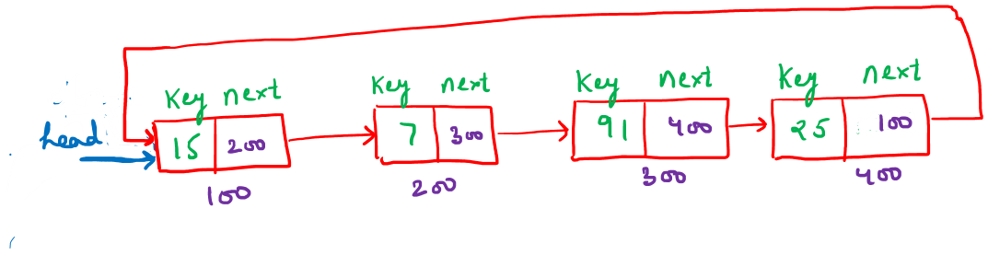

Gate Questions CLL
 | GATE 2013
 | How do you identify the end of a circular linked list during traversal?
AN | When the current node again becomes equal to the starting node.

 | GATE 2019
 | Which condition replaces temp != NULL in a circular linked list traversal?
AN | temp != head (after first iteration)

Practice Questions CLL

S.No | Problem Name | Link
1 | Linked List Cycle | https://leetcode.com/problems/linked-list-cycle/description/
2 | Reverse Linked List | https://leetcode.com/problems/reverse-linked-list/
3 | Linked List Cycle II | https://leetcode.com/problems/linked-list-cycle-ii/

Doubly Linked List
A doubly linked list is similar to a singly linked list, except that each node has two links:
- next → points to the next node
- prev → points to the previous node
Entry to the list is through the head node, which is usually marked. The operations are similar to singly linked list operations, with small modifications to handle the prev link.
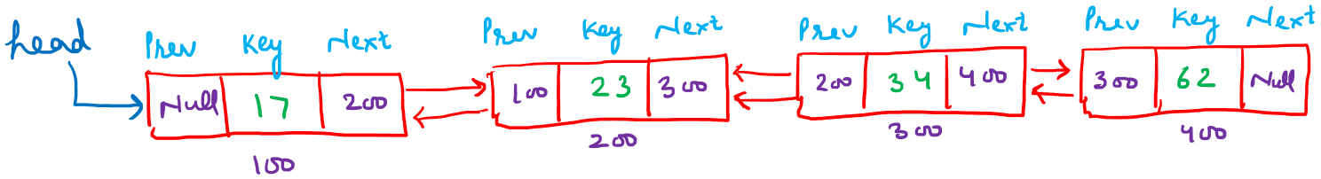
Operations:
We will cover the following basic operation for node creation:

Creation
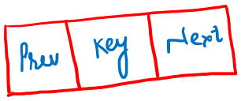

Algorithm createNode(value)
- create a new node (newNode)
- set newNode.data <- value
- set newNode.next <- NULL
- set newNode.prev <- NULL
- return newNode

C++ Code

#include <iostream>

using namespace std;

class Node {
public: int data;
Node * next;
Node * prev;

// Constructor
Node(int value) {
data = value;
next = nullptr;
prev = nullptr;
}
};

// Function to create a new node
Node * createNode(int value) {
// call constructor
Node * newNode = new Node(value);
return newNode;
}

int main() {
int value;
cin >> value;

Node * node = createNode(value);

cout << "Node created successfully!" << endl;
cout << "Data = " << node -> data << endl;
// will display 0 or NULL
cout << "Next = " << node -> next << endl;
// will display 0 or NULL
cout << "Prev = " << node -> prev << endl;

return 0;
}

Complexity:
Creating a node in a doubly linked list is O(1), just like in a singly linked list.

Searching
Looking for the given key in the structure
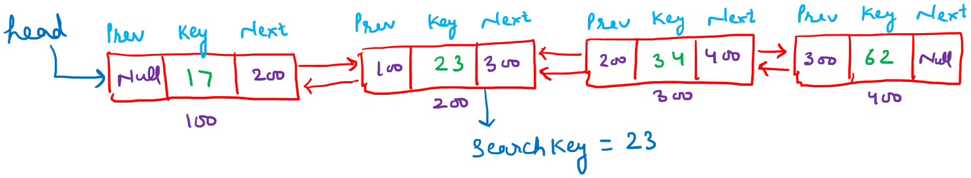
Algorithm search(head, key)
- set temp <- head
- while temp != NULL do
- if temp.data = key then
i. return true
- end if
- set temp <- temp.next
- end while
- return false

C++ Code:
bool search(Node * head, int key) {
Node * current = head;
while (current != nullptr) {
if (current -> data == key) return true;
current = current -> next;
}
return false;
}

Insertion
Inserting the given key into the structure. Insertion is possible in 4 different ways:
- At beginning
- At end
- At any index
- After some particular value.
Insertion at Beginning
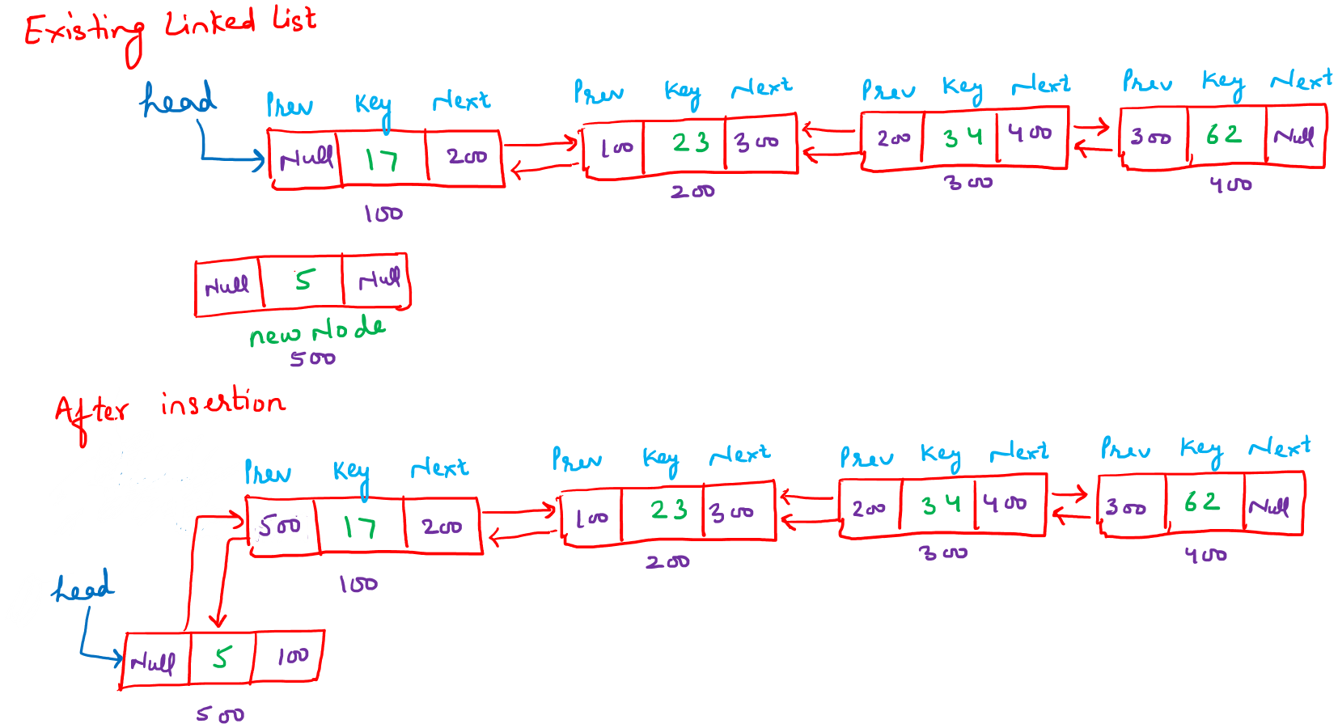

Algorithm insertAtBeginning(head, value)

- create a new node (newNode)
- set newNode.data <- value
- set newNode.next <- NULL
- set newNode.prev <- NULL
- if head != NULL then
- set head.prev <- newNode
- end if
- set head <- newNode
- return head

C++ Code:

Node * insertAtBeginning(Node * head, int value) {
// create new node
Node * newNode = new Node(value);
// new node points to old head
newNode -> next = head;
// previous of new node is NULL
newNode -> prev = nullptr;
// old head points back to new node
if (head != nullptr) head -> prev = newNode;
head = newNode; // update head
return head;
}
Complexity
Explain that every statement of the above algorithm is a constant time operation. Hence suggest that Insertion at the beginning is of constant time i.e. O(1).
Insertion at the End
Insert a given node (newNode) in a doubly linked list at the last position. You are given the reference of the first node of the DLL (head). The newNode has three fields (key, next, and prev).
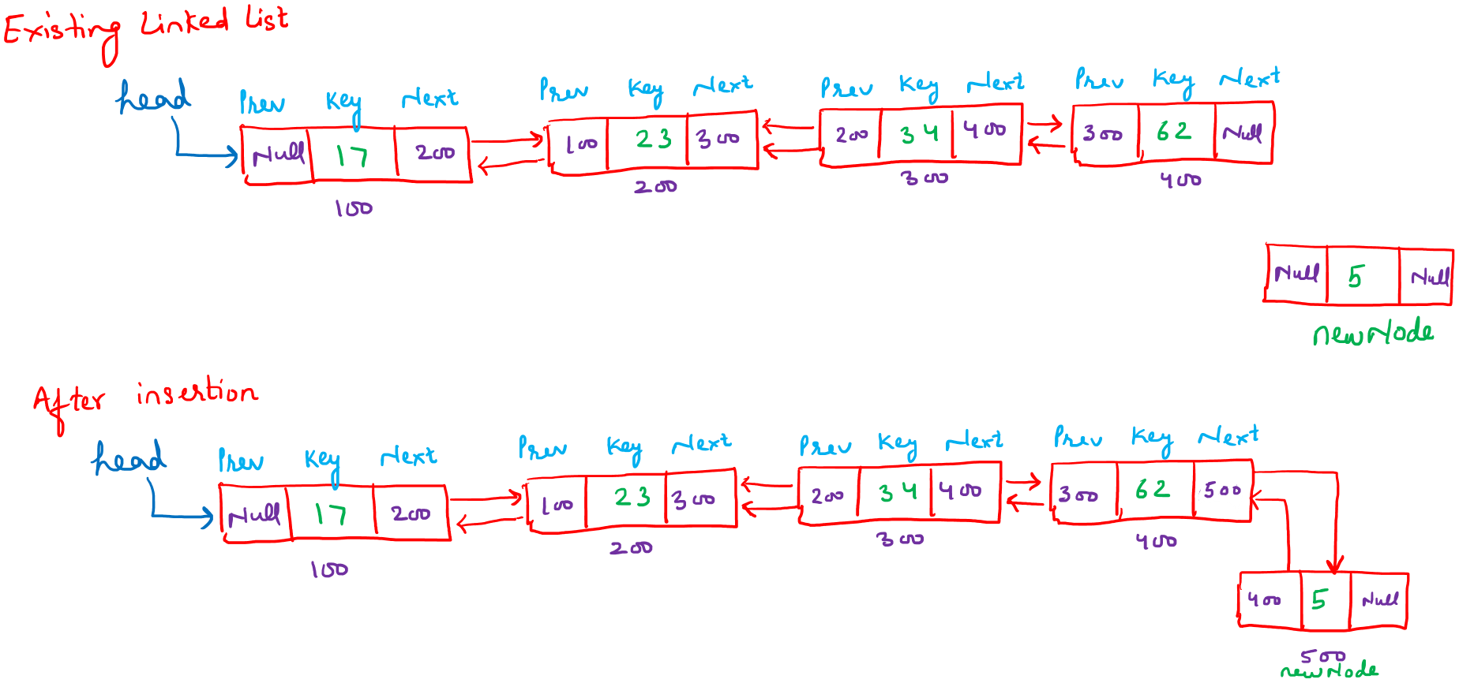
Algorithm insertAtEnd(head, value)
- create a new node (newNode)
- set newNode.data <- value
- set newNode.next <- NULL
- set newNode.prev <- NULL
- if head = NULL then
- return newNode
- end if
- set temp <- head
- while temp.next != NULL do
- set temp <- temp.next
- end while
- set temp.next <- newNode
- set newNode.prev <- temp
- return head

C++ Code:

Node * insertAtEnd(Node * head, int value) {
// create new node
Node * newNode = new Node(value);
newNode -> next = nullptr;
newNode -> prev = nullptr;

// If the list is empty
if (head == nullptr) {
// new node becomes head
return newNode;
}

Node * temp = head;

// Traverse to the last node
while (temp -> next != nullptr) {
temp = temp -> next;
}

// Attach new node at the end
temp -> next = newNode;
newNode -> prev = temp;

return head; // return unchanged head
}

Complexity

Traversal is required to reach the last node since only the head pointer is maintained.
So, the time complexity is O(n).
Insertion at end (Special Case)
Insert a given node (newNode) in a Doubly Linked List at the last position. You are given the reference of the first node and last node of the DLL (head and tail). The newNode has three fields (key, next, and prev). Initially, newNode.next = NULL and newNode.prev = NULL.
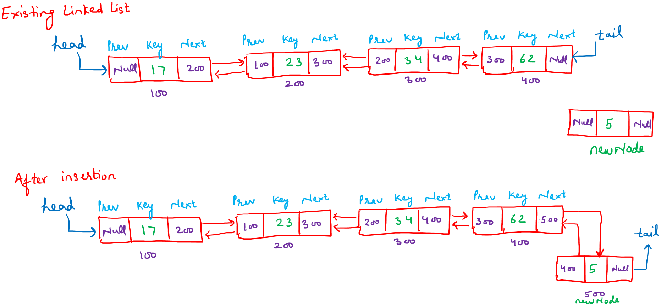

Algorithm insertAtEnd(head, tail, newNode)
- create a new node (newNode)
- set newNode.data <- value
- set newNode.next <- NULL
- set newNode.prev <- NULL
- if head = NULL then
- set head <- newNode
- set tail <- newNode
- return
- end if
- set tail.next <- newNode
- set newNode.prev <- tail
- set tail <- newNode
C++ Code:
void insertAtEnd(Node * & head, Node * & tail, Node * newNode) {

// If list is empty
if (head == nullptr) {
head = newNode;
tail = newNode;
return;
}

// Attach at the end
tail -> next = newNode;
newNode -> prev = tail;

// Update tail pointer
tail = newNode;
}

Complexity
Since insertion is performed directly using the tail pointer, Insertion at end takes constant time: O(1).
Insertion at Given Index
Insert a given node (newNode) in a Doubly Linked List (DLL) at a specified index (index). It is assumed that index ≥ 0 and index ≤ length − 1. You are given the reference of the first node (head). Each node has three fields: data, next, and prev. The newNode has next = NULL and prev = NULL.
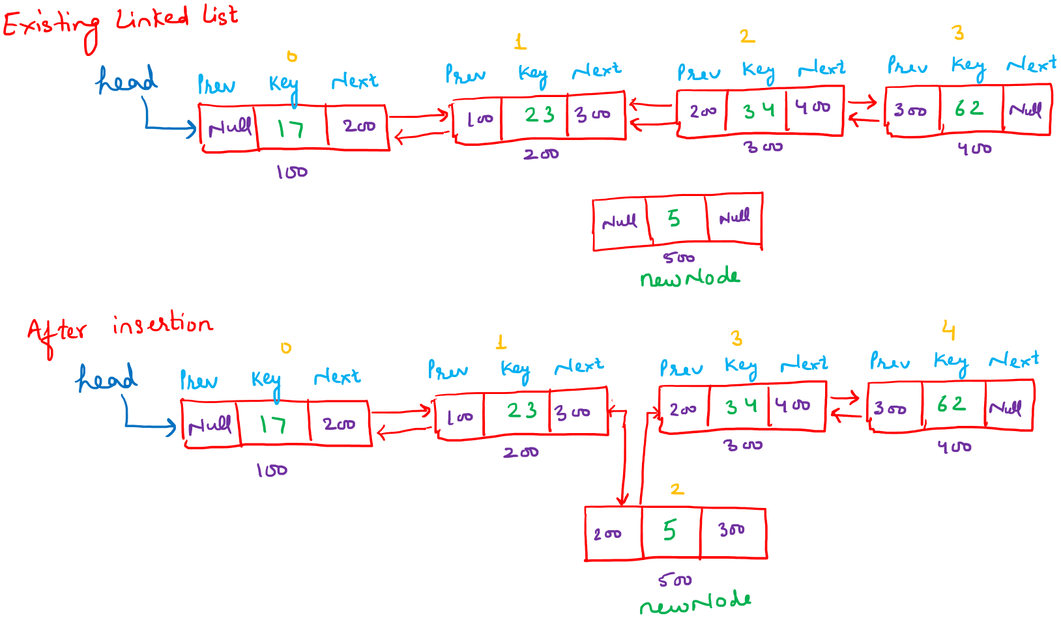

Algorithm insertAtIndex(head, index, value)

- create a new node newNode
- set newNode.data <- value
- set newNode.next <- NULL
- set newNode.prev <- NULL
- if index = 0 then
- set newNode.next <- head
- set newNode.prev <- NULL
- if head != NULL then
i. set head.prev <- newNode
- end if
- return newNode
- end if
- set temp <- head
- set currentIndex <- 0
- while temp != NULL and currentIndex < index - 1 do
- set temp <- temp.next
- set currentIndex <- currentIndex + 1
- end while
- if temp = NULL then
- print "Index out of range"
- delete newNode
- return head
- end if
- set newNode.next <- temp.next
- set newNode.prev <- temp
- if temp.next != NULL then
- set temp.next.prev <- newNode
- end if
- set temp.next <- newNode
- return head

C++ Code
Node * insertAtIndex(Node * head, int index, int value) {
Node * newNode = new Node(value);

// Insert at beginning
if (index == 0) {
newNode -> next = head;
newNode -> prev = nullptr;
if (head != nullptr) {
head -> prev = newNode;
}
return newNode; // new node becomes head
}

Node * temp = head;
int currentIndex = 0;

// Move to (index - 1) position
while (temp != nullptr && currentIndex < index - 1) {
temp = temp -> next;
currentIndex++;
}

// If index is out of range
if (temp == nullptr) {
cout << "Index out of range!\n";
delete newNode;
return head;
}

// Insert node
newNode -> next = temp -> next;
newNode -> prev = temp;

if (temp -> next != nullptr) {
temp -> next -> prev = newNode;
}

temp -> next = newNode;

return head;
}

Complexity
The algorithm traverses the DLL up to the point of insertion. Thus, the time complexity is O(n).
Insert after some particular value
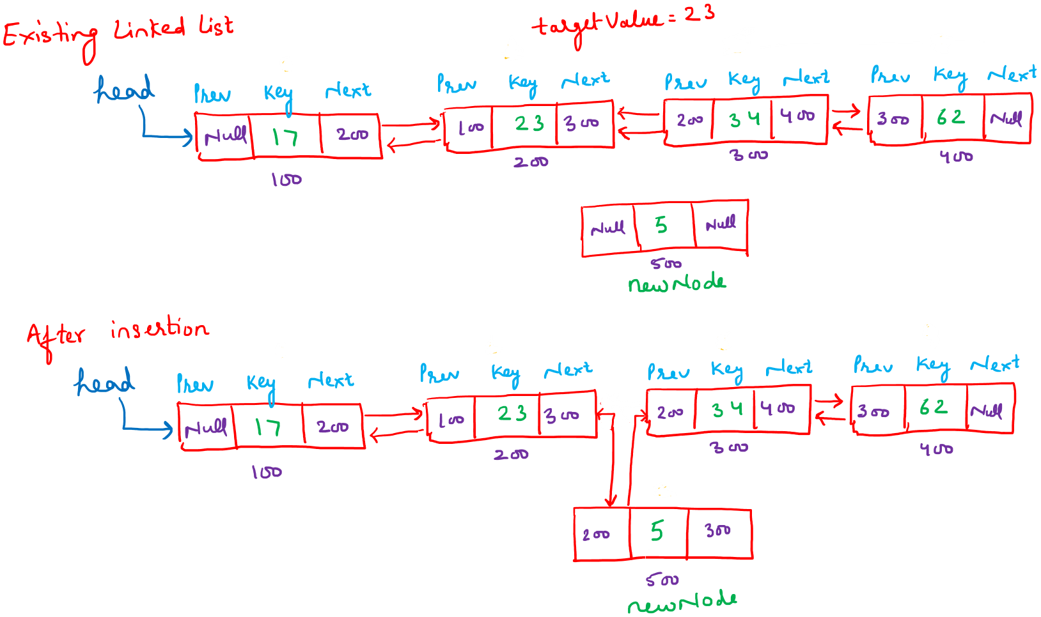
Algorithm insertAfterValue(head, target, value)
- create a new node newNode
- set newNode.data <- value
- set newNode.next <- NULL
- set newNode.prev <- NULL
- set temp <- head
- while temp != NULL and temp.data != target do
- set temp <- temp.next
- end while
- if temp = NULL then
- print "value not found"
- return head
- end if
- set newNode.next <- temp.next
- set newNode.prev <- temp
- if temp.next != NULL then
- set temp.next.prev <- newNode
- end if
- set temp.next <- newNode
- return head
C++ Code
Node * insertAfterValue(Node * head, int target, int value) {
Node * temp = head;

// Search for the target value
while (temp != nullptr && temp -> data != target) {
temp = temp -> next;
}

// Target not found
if (temp == nullptr) {
cout << "Value " << target << " not found in the list!\n";
return head;
}

// Create new node
Node * newNode = new Node(value);

// Link new node
newNode -> next = temp -> next;
newNode -> prev = temp;

// Update next node's prev pointer if it exists
if (temp -> next != nullptr) {
temp -> next -> prev = newNode;
}

// Link target node to new node
temp -> next = newNode;

return head;
}

Complexity
The algorithm traverses the DLL up to the point of insertion. Thus, the time complexity is O(n).

Deletion
Deletion of a node in a Doubly Linked List (DLL) can be performed in four different ways:
- From the beginning
- From the end
- At a given index
- Node with a particular value
Each node has three fields: data, next, and prev.

Deletion from the Beginning
You are given the reference of the first node of the DLL (head). Delete the first node of the list.
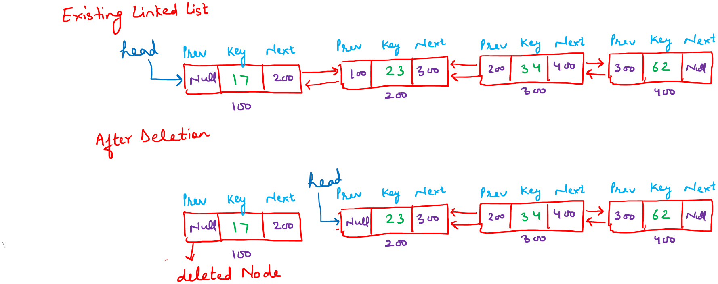
Algorithm deleteFromBeginning(head)

- if head = NULL then
- return NULL
- end if
- if head.next = NULL then
- delete head
- return NULL
- end if
- set temp <- head
- set head <- head.next
- set head.prev <- NULL
- delete temp
- return head

C++ Code
Node * deleteFromBeginning(Node * head) {
if (head == nullptr) {
return nullptr;
}

// Single node
if (head -> next == nullptr) {
delete head;
return nullptr;
}

Node * temp = head;
head = head -> next;
head -> prev = nullptr;
delete temp;

return head;
}
Complexity
Explain that every statement of the above algorithm is a constant time operation. Hence suggest that Insertion at the beginning is of constant time i.e. O(1).
Deletion from the End
You are given the reference of the first node of the DLL (head). Delete the last node.
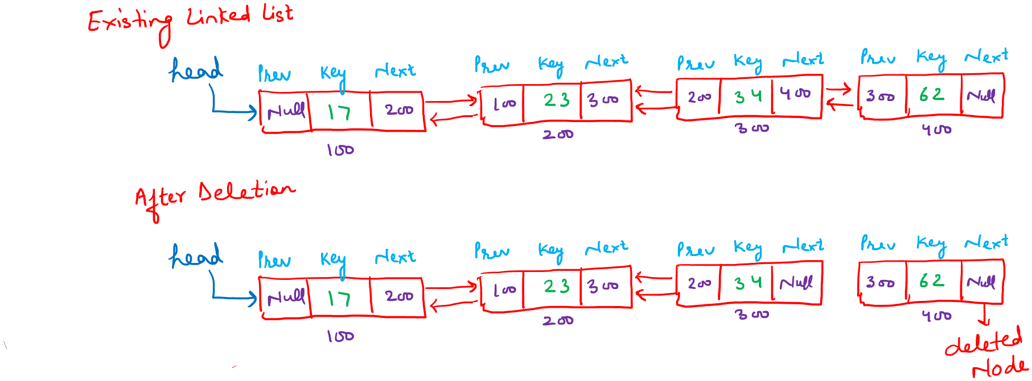
Algorithm deleteFromEnd(head)

- if head = NULL then
- return NULL
- end if
- if head.next = NULL then
- delete head
- return NULL
- end if
- set temp <- head
- while temp.next != NULL do
- set temp <- temp.next
- end while
- set temp.prev.next <- NULL
- delete temp
- return head

C++ Code
Node * deleteFromEnd(Node * head) {
if (head == nullptr) {
return nullptr;
}

// Single node
if (head -> next == nullptr) {
delete head;
return nullptr;
}

Node * temp = head;
while (temp -> next != nullptr) {
temp = temp -> next;
}

temp -> prev -> next = nullptr;
delete temp;

return head;
}
Complexity
The algorithm traverses the DLL up to the point of deletion. Thus, the time complexity is O(n).
Deletion from the end (Special Case)
You are given the reference of the first node of the SLL (head)and the reference of the last node of the DLL (Tail). Delete the last node of this linked list.
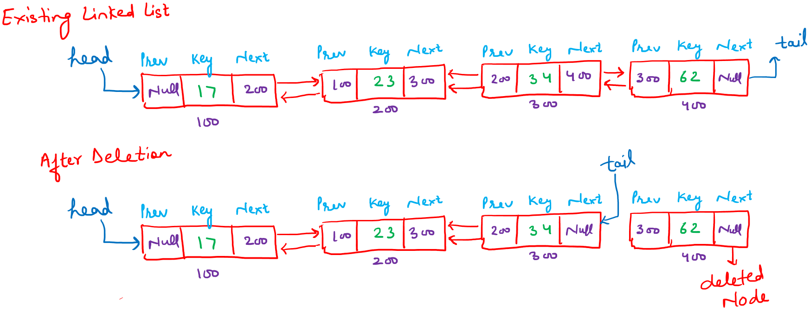
Algorithm deleteLastNode(head, tail)

- if head = NULL then
- return
- end if
- if head = tail then
- delete head
- set head <- NULL
- set tail <- NULL
- return
- end if
- set delNode <- tail
- set tail <- tail.prev
- set tail.next <- NULL
- delete delNode

C++ Code
void deleteLastNode(Node * & head, Node * & tail) {
// Empty list
if (head == nullptr) {
return;
}

// Single node
if (head == tail) {
delete head;
head = nullptr;
tail = nullptr;
return;
}

// Delete last node
Node * delNode = tail;
tail = tail -> prev;
tail -> next = nullptr;
delete delNode;
}

Complexity
Since deletion is performed directly using the tail pointer, deletion at end when tail pointer given takes constant time: O(1).
Deletion at a Given Index
Delete a node from a DLL at a given index (index ≥ 0).
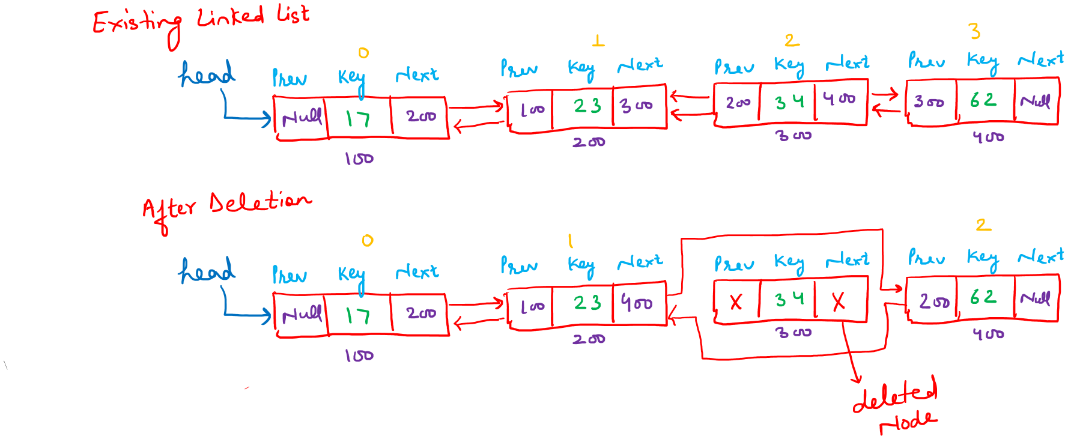
Algorithm deleteAtIndex(head, index)

- if head = NULL then
- return NULL
- end if
- if index = 0 then
- set temp <- head
- set head <- head.next
- if head != NULL then
i. set head.prev <- NULL
- end if
- delete temp
- return head
- End if
- set temp <- head
- set currentIndex <- 0
- while temp != NULL and currentIndex < index do
- set temp <- temp.next
- set currentIndex <- currentIndex + 1
- end while
- if temp = NULL then
- return head
- end if
- set temp.prev.next <- temp.next
- if temp.next ≠ NULL then
- set temp.next.prev <- temp.prev
- end if
- delete temp
- return head
C++ Code

Node * deleteAtIndex(Node * head, int index) {
if (head == nullptr) {
return nullptr;
}

// Delete first node
if (index == 0) {
Node * temp = head;
head = head -> next;
if (head != nullptr) {
head -> prev = nullptr;
}
delete temp;
return head;
}

Node * temp = head;
int currentIndex = 0;

while (temp != nullptr && currentIndex < index) {
temp = temp -> next;
currentIndex++;
}

if (temp == nullptr) {
return head;
}

temp -> prev -> next = temp -> next;
if (temp -> next != nullptr) {
temp -> next -> prev = temp -> prev;
}

delete temp;
return head;
}

Complexity
The algorithm traverses the DLL up to the point of deletion. Thus, the time complexity is O(n).

Deletion After a Given Value
Delete the node that appears immediately after the first node containing targetValue.
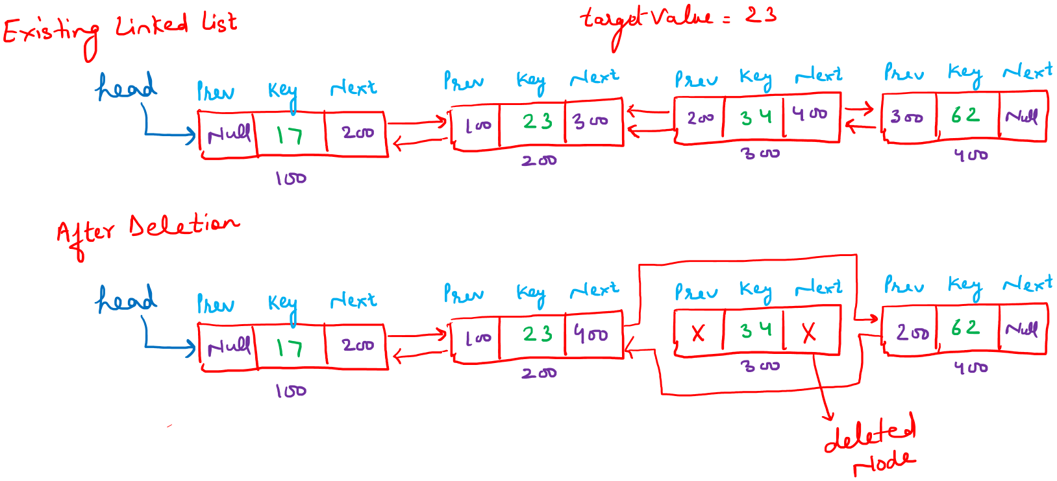
Algorithm: DeleteAfterValue(head, targetValue)

- set temp <- head
- while temp != NULL and temp.data != targetValue do
- set temp <- temp.next
- end while
- if temp = NULL or temp.next = NULL then
- return head
- end if
- set delNode <- temp.next
- set temp.next <- delNode.next
- if delNode.next != NULL then
- set delNode.next.prev <- temp
- end if
- delete delNode
- return head

C++ Code

Node * deleteAfterValue(Node * head, int targetValue) {
Node * temp = head;

while (temp != nullptr && temp -> data != targetValue) {
temp = temp -> next;
}

if (temp == nullptr || temp -> next == nullptr) {
return head;
}

Node * delNode = temp -> next;
temp -> next = delNode -> next;

if (delNode -> next != nullptr) {
delNode -> next -> prev = temp;
}

delete delNode;
return head;
}
Complexity
The algorithm traverses the DLL up to the point of deletion. Thus, the time complexity is O(n).

Gate Questions DLL

 | GATE 2022
 | N items are stored in a sorted doubly linked list. For a delete operation, a pointer is provided to the record to be deleted. For a decrease-key operation, a pointer is provided to the record on which the operation is to be performed. An algorithm performs the following operations on the list in this order: Θ(N) delete, O(logN) insert, O(logN) find, and Θ(N) decrease-key. What is the time complexity of all these operations put together?
A | O(log2N)
B | O(N)
C | O(N^2)
D | Θ(N2logN)
AN | C

 | GATE 2023
 | Let SLLdel be a function that deletes a node in a singly-linked list given a pointer to the node and a pointer to the head of the list. Similarly, let DLLdel be another function that deletes a node in a doubly-linked list given a pointer to the node and a pointer to the head of the list. Let n denote the number of nodes in each of the linked lists. Which one of the following choices is TRUE about the worst-case time complexity of SLLdel and DLLdel?
A | SLLdel is O(1) and DLLdel is O(n)
B | Both SLLdel and DLLdel are O(log(n))
C | Both SLLdel and DLLdel are O(1)
D | SLLdel is O(n)andDLLdel is O(1)
AN | D

 | GATE 2010
 | What extra information does a doubly linked list node store compared to a singly linked list node?
AN | A pointer to the previous node

 | GATE 2018
 | Which operation is more efficient in a doubly linked list compared to a singly linked list?
AN | Deletion of a given node

 | GATE 2016
N items are stored in a sorted doubly linked list. For a delete operation, a pointer is provided to the record to be deleted. For a decrease-key operation, a pointer is provided to the record on which the operation is to be performed.

An algorithm performs the following operations on the list in this order:Θ(N) delete, O(logN) insert, O(logN) find, Θ(N) decrease-key

What is the time complexity of all these operations put together?
A | O(logN)
B | O(N)
C | O(N^2)
D | Θ(N^2.logN)
AN | C

Practice Questions DLL

S.No | Problem Name | Link
1 | Minimum Pair Removal to Sort Array I | https://leetcode.com/problems/minimum-pair-removal-to-sort-array-i/description/
2 | Flatten a Multilevel Doubly Linked List | https://leetcode.com/problems/flatten-a-multilevel-doubly-linked-list/

Doubly Circular Linked List
A Doubly Circular Linked List is an extension of a Doubly Linked List (DLL) in which the nodes are connected in a circular manner. Each node contains three fields: data, next, and prev. Just like a doubly linked list, every node stores a reference to both its next and previous nodes.
The only difference between a Doubly Circular Linked List and a Doubly Linked List is in the end connections. In a DCLL, the next pointer of the last node points to the first node (head), and the prev pointer of the first node points to the last node (tail). There is no NULL pointer in the list.
All operations such as creation, insertion, deletion, and traversal are exactly the same as in a Doubly Linked List, with the small additional care that traversal must stop when the starting node is reached again instead of checking for NULL.
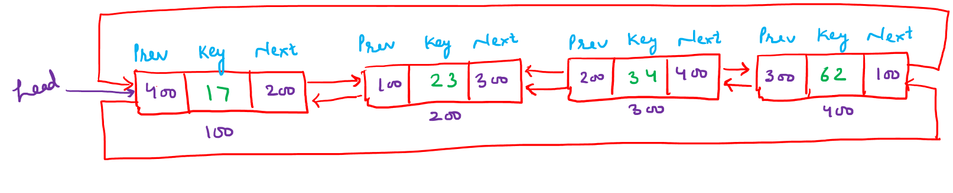

Complexity Comparison
Below is a summary of time complexities of all basic operations for:

- Singly Linked List (SLL)
- Doubly Linked List (DLL)
- Circular Linked List (CLL)
- Doubly Circular Linked List (DCLL)

Operation | SLL | DLL | CLL | DCLL | Remarks
Creation | O(1) | O(1) | O(1) | O(1) | Create a single node
Searching | O(n) | O(n) | O(n) | O(n) | Sequential traversal
Insertion at Beginning | O(1) | O(1) | O(1) | O(1) | Head update only
Insertion at End (only head) | O(n) | O(n) | O(n) | O(n) | Traverse till last
Insertion at End (head + tail) | O(1) | O(1) | O(1) | O(1) | Tail pointer used
Insertion at Given Index | O(n) | O(n) | O(n) | O(n) | Traverse to index
Insertion After Value | O(n) | O(n) | O(n) | O(n) | Search dominates
Deletion from Beginning | O(1) | O(1) | O(1) | O(1) | Direct head removal
Deletion from End (only head) | O(n) | O(n) | O(n) | O(n) | Need predecessor
Deletion from End (head, tail, second-last) | O(1) | O(1) | O(n) | O(1) | DLL has backward link
Deletion from Given Index | O(n) | O(n) | O(n) | O(n) | Traverse required
Deletion by Value | O(n) | O(n) | O(n) | O(n) | Search + delete

How Linked List is used in popular languages

Language designers usually do not choose linked lists as the default data structure because arrays and dynamic arrays are easier to use, faster for most common operations, and more efficient in terms of memory and CPU cache usage. Arrays store elements in contiguous memory, which allows quick indexing and faster traversal, making them ideal for everyday programming tasks. Linked lists, on the other hand, require extra memory for pointers and do not support direct access to elements, which can make them slower and more complex to work with.

However, linked lists are still important for certain situations where frequent insertions and deletions are needed or memory cannot be allocated contiguously. For this reason, most programming languages provide linked list implementations as an option, even though arrays or dynamic arrays remain the default choice.

Language | Default Structure  (Dynamic Arrays) | Linked List Support | Reference
C++ | std::vector | std::list, std::forward_list | https://en.cppreference.com/w/cpp/container
Java | ArrayList | LinkedList | https://docs.oracle.com/en/java/javase/25/docs/api/java.base/java/util/LinkedList.html
Python | list | collections.deque | https://docs.python.org/3/library/collections.html

Codechef Problems
S.No | Problem Name | Link
1 | Search in Linked List | https://www.codechef.com/practice/course/linked-lists/LINKLISTF/problems/SEARCHLL
2 | Length of Linked List | https://www.codechef.com/practice/course/linked-lists/LINKLISTF/problems/LINKLEN
3 | Find Middle Element of Linked List | https://www.codechef.com/practice/course/linked-lists/LINKLISTF/problems/LLMID
4 | PREP55 (Basic Linked List Prep) | https://www.codechef.com/practice/course/linked-lists/LINKLISTF/problems/PREP55
5 | PREP58 (Cycle in a Linked List) | https://www.codechef.com/practice/course/linked-lists/LINKLISTF/problems/PREP58
6 | CRITLIST (Critical Points in Linked List) | https://www.codechef.com/practice/course/linked-lists/LINKLISTF/problems/CRITLIST

